K.P.C PUBLIC SCHOOL, KHARGHAR
ASSESSMENT - V (2022-2023)
GRADE:VI MARKS:40
SUBJECT:SCIENCE TIME :2 HRS

Q1.Fill in the blanks:
- Water is known as ________ solvent.
- The smallest unit into which something can be divided is known as an ______.
- _________ bone is broken most often.
- A compass is a _________ instrument.
- The leaves are green due to the presence __________ .
- When air moves slowly , it is called _______ .
Q2. Match the columns: [5M]
Column A | Column B
1. Irreversible change | a. Do not emit light of their own
2. Magnetic material | b. Does not support combustion
3. Non-luminous | c. Biogas
4. Carbon dioxide | d. Blooming of a flower
5. Kitchen waste | e. Magnetite

Q3. Distinguish between the following: [6M]
- Reversible and Irreversible changes
- Troposphere and Stratosphere
Q4. Identify the odd man out with reason [3M]
- Helium , Argon , Neon , Oxygen
- Salt, sugar, water, lemon juice
- Sun, Stars, Fireflies, Moon
Q5. Answer in short: [5M]
- Which layer of the atmosphere protects the Earth from ultraviolet rays?
- What is a magnet?
- Name the gases obtained by passing electricity through water.
- List some modern day uses of magnet.
- What are decomposers?
Q6. Write whether the following statements are ‘True’ or ‘False’: [5M]
- The liquid waste released by industries is in the form of effluents.
- Stems absorb water and minerals from the soil.
- Heating a substance does not cause any change.
- Light travelling in curved line is known as rectilinear propagation of light.
- The process of settling down of insoluble solids in a liquid is called decantation.
Q7. Label the following diagram. [4M]
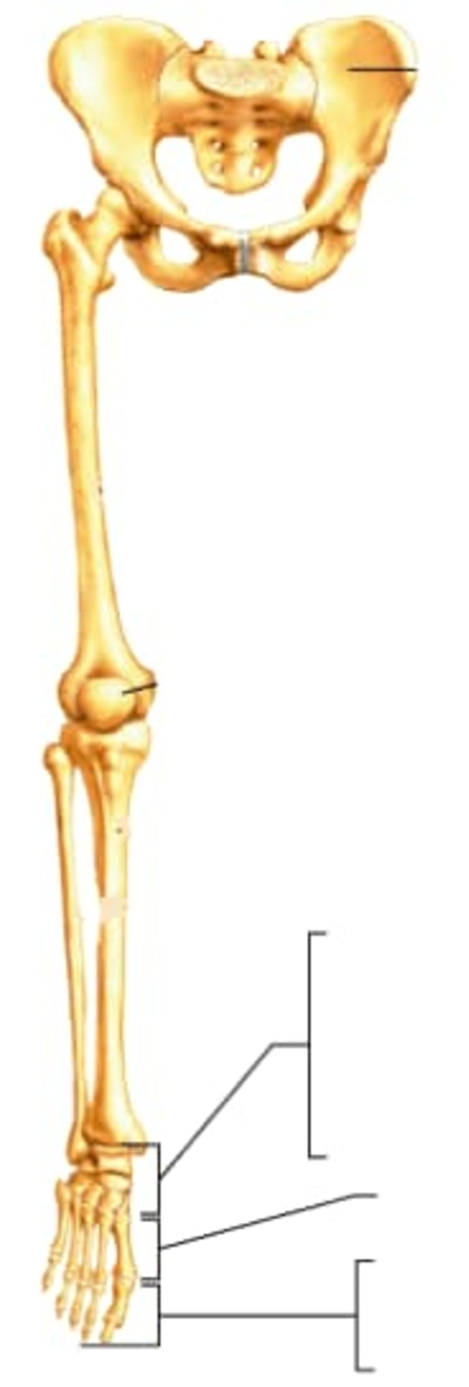
Q8. Long answer questions: {Any two} [6M] 1. What are physical changes? Give examples
2. Write the harmful effects of air pollution.
3. Name the types of joints in our body and give examples of each.
4. How is waste categorised based on their different characteristics?

